Olivet Presbyterian Church

159 Church Street, McConnells, South Carolina (803) 693-4040

Email: olivet_pca@bellsouth.net On the web: www.olivetpca.org
John M. “Chip” McArthur, Jr., Pastor
Austin R. Simpson, Ministerial Intern
Christopher McCartney, Choir Director/Accompanist
Robert B. Mendenhall, Sunday School Superintendent

The Session
Christopher W. Arnold Roy G. Clinton, Emeritus David R. Currence, Emeritus
Jeffery E. Fairfax, Emeritus Daniel H. Harshaw James M. Hawley, Emeritus
Robert B. Mendenhall John M. McArthur, Jr. Moderator Jason M. Petty Richard B. Summerville, Jr. William Lee Summerville, Jr., Clerk

The Diaconate
Brian J. Carlisle, Widows & Shut-ins Brent M. Christenberry, Buildings & Grounds James R. Clinton Lee K. Guempel, Safety Team Malcolm Harshaw, Treasurer John F. Hawley, Chairman Don L. Johnson David W. Kelley Michael A. Laws, Secretary Larry M. Plyler, Emeritus

The Women in the Church
Sandra Currence, President Kathy Fairfax, Nursery/Children’s Church Susan Petty, Secretary Ina Ruth Johnson, Historian Marsha Plyler, Treasurer/Pastor's Aide Lorie Rohrer, Missions Frankie Guempel, Chair-Circle 2

Our Missionaries
Peter and Diane Bakelaar (MTW-Japan) Brian Howard (RUFI-Clemson Univ.)
Garry and Anita Chambers (MTW-Caribbean) Sara Driggers (Wycliffe)
Roger and Laura Dye (Family Life Global-Latin America) Debbie Richards (MTW-Japan)

Ministry Committees, 2023

Discipleship Ministries Committee
Chris Arnold (2024), Chairman Brenda Nance (2023)
Jill Christenberry (2024) Donna McArthur (2025)
Rick Summerville (2026) Kathy Fairfax (2025)

Missions Committee
Bobby Mendenhall (2024), Chairman Susan Petty (2023)
Brian Carlisle (2024) Thomas Hardison (2025)
Jason Petty (2026) Lori Rohrer (2025)

Witness Committee
Daniel Harshaw (2026), Chairman Laura Frame (2023)
Katie Summerville (2024) Marsha Plyler (2026)
Scharlie Carlisle (2026)

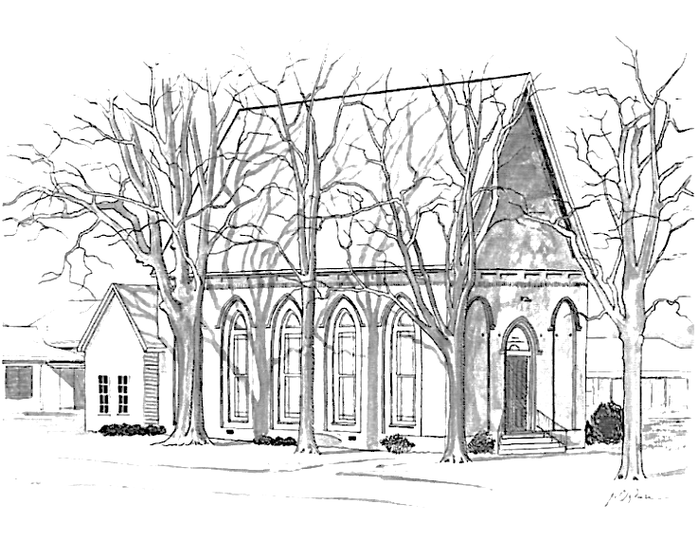

Olivet Presbyterian Church
McConnells, South Carolina

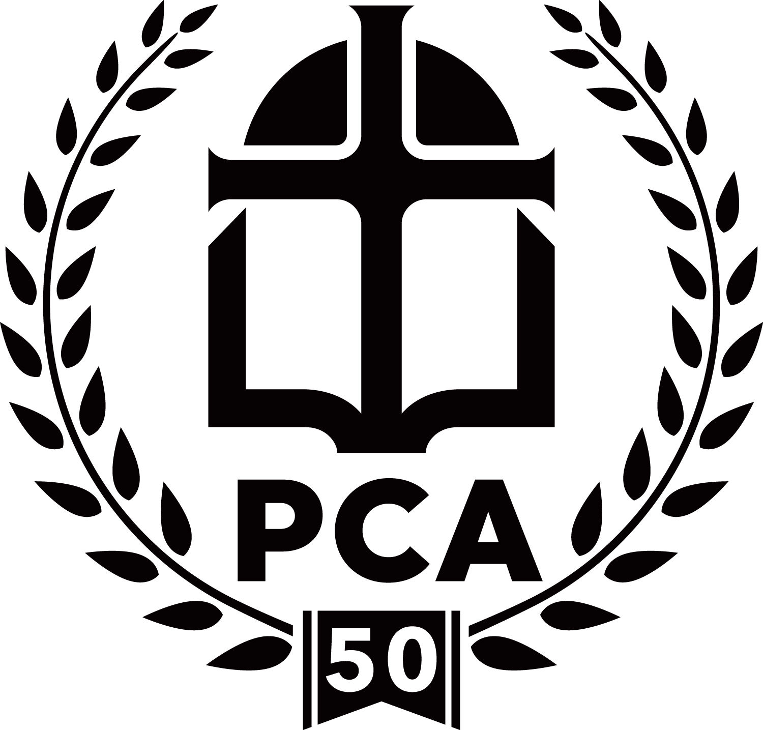

A member congregation of
The Presbyterian Church in America

Olivet Presbyterian Church
The Lord’s Day, October 29, 2023
Prelude Preparation for Worship
Welcome and Announcements
*Call to Worship Pastor Chip McArthur
B
lessed be the Lord, the God of Israel,
From everlasting to everlasting!
And let all the people say, “Amen!”
Praise the Lord!
(Psalm 106:48, ESV)
*Hymn 76 Praise My Soul, the King of Heaven All
*Invocation and the Lord’s Prayer
*Hymn 164 O for a Thousand Tongues to Sing All
The Law of God Mr. Austin Simpson
Leader: What is the ninth commandment?
People: The ninth commandment is: You shall not give false testimony against your neighbor.
Leader: What does the ninth commandment require?
People: The ninth commandment requires us to tell the truth and to maintain and promote it and out own and others’ reputations, especially when testifying.
Leader: What does the ninth commandment forbid?
People: The ninth commandment forbids anything that gets in the way of the truth or injures anyone’s reputation.
From The Westminster Shorter Catechism, Questions 76-78
Confession of Sin Unison Reading
Merciful Lord, we confess that with us there is an abundance of sin, but in You there is the abundance of mercy. Oh, how we need your mercy. We are empty vessels that need to be filled; fill us. We are weak in faith; strengthen us. We are cold in love; warm us, that our love may go out to one another and to our neighbors for Your glory, through Jesus Christ our Lord.

Assurance of Pardon
The steadfast love of the Lord is from everlasting to everlasting on those who fear him, and his righteousness to children’s children.
(Psalm 103:17, ESV)
Pastoral Prayer
His Tithes & Our Offerings
*Doxology
*Prayer of Thanksgiving
*Hymn 308 Jesus Paid It All All
Children’s Message Mr. Simpson
(Children aged 3 to 5 years dismissed to Children’s Church Program)
Scripture Reading John 19:38-42
Sermon “Dead and Buried” Pastor McArthur
*Hymn 499 Rock of Ages, Cleft for Me All
*Benediction
*Offering of Praise 735 The Gloria Patri All
Glory be to the Father, and to the Son and to the Holy Ghost; as it was in the beginning, is now and ever shall be, world without end. Amen, amen.
*Postlude
*Those who are able, please stand.

Today at Olivet
8:45 am Early Prayer (in Pastor’s Study)
9:00 am Sunday School
10:00 am Morning Worship
5:00 pm Choir Practice
6:00 pm Fifth Sunday Joint Worship at Bullock Creek PCA. A time of fellowship and refreshments will follow. Bring finger foods.
This Week at Olivet
Wednesday Youth Group Meeting, 6 pm
Prayer Meeting at 7 pm (Conference Room)
Looking Ahead
November 5 Session Meeting, 4 pm
November 7 Municipal Election Day (McConnells Precinct voting at Olivet)
November 10 RUF-Winthrop Barn Dance – Olivet Picnic Shelter
November 17-19 Youth Fall Retreat at Ridgehaven
November 19 Deadline for Operation Christmas Child shoeboxes
Annual Joint Thanksgiving Service with McConnells First Baptist (Olivet hosting), 6 pm
Faith Promise for World Missions
2023 Faith Promise pledged April 30, 2023: $ 19,340.00
2023 Faith Promise received to date: $ 11,927.50
Church Budget Matters
Budget requirements to date $ 167,227.43
Receipts to date: $ 170,834.87
Collection Duty
October Brent Christenberry, Don Johnson, Jamie Clinton
November Malcolm Harshaw, David Kelley, Brian Carlisle
Nursery Team
Today (10/29) Addisyn Sikes, Barbara Lawson
Next Sunday (11/5) Gracie Horton, Gwen Carlisle
Children’s Church Team
Today (10/29) Brenda Nance(T), Richard Sikes
Next Sunday (11/5) Scharlie Carlisle(T), Toni Clinton
Devotional Guides
The latest editions of Our Daily Bread and Tabletalk, as well as the PCA’s ByFaith Magazine are now available in the vestibule. Pick up your copy today.
Sermon Notes for Kids
“Kids’ Sermon Notes” are available in the kids’ baskets to help our children to follow along with our worship service. Please encourage your kids to participate by filling out their copy, and then sharing their notes with any elder or deacon to receive a treat.

Kelly, Douglas F., et al. The Westminster Shorter Catechism in Modern English. Presbyterian and Reformed Publishing Company, 1986.

