Olivet Presbyterian Church

159 Church Street, McConnells, South Carolina (803) 693-4040

Email: olivet_pca@bellsouth.net On the web: www.olivetpca.org
John M. “Chip” McArthur, Jr., Pastor
Austin R. Simpson, Assistant Pastor
Christopher McCartney, Choir Director/Accompanist
Robert B. Mendenhall, Sunday School Superintendent

The Session
Christopher W. Arnold Brian J. Carlisle Roy G. Clinton, Emeritus
David R. Currence, Emeritus Jeffery E. Fairfax, Emeritus Lee K. Guempel
Daniel H. Harshaw, Clerk James M. Hawley, Emeritus John M. McArthur, Jr. Moderator
Robert B. Mendenhall Jason M. Petty Richard B. Summerville, Jr., Emeritus W. Lee Summerville, Jr.

The Diaconate
James R. Clinton Malcolm Harshaw John F. Hawley, Chairman
Don L. Johnson Peter G. Lawson Michael A. Laws, Secretary
Richard B. Sikes Larry M. Plyler, Emeritus
Brent M. Christenberry, Buildings & Grounds, Treasurer

The Women in the Church
Sandra Currence, President Kathy Fairfax, Nursery/Children’s Church Susan Petty, Secretary Ina Ruth Johnson, Historian Marsha Plyler, Treasurer/Pastor's Aide Lorie Hawley, Missions Frankie Guempel, Circle Chair

Our Missionaries
Peter and Diane Bakelaar (MTW-Japan) Brian Howard (RUFI-Clemson Univ.)
Garry and Anita Chambers (MTW-Caribbean) Sara Driggers (Wycliffe)
Roger and Laura Dye (Family Life – U.S. Latino)

Ministry Committees, 2025

Discipleship Ministries Committee
Rick Summerville, Chairman (2026) Donna McArthur (2025)
Kathy Fairfax (2025) Susan Petty (2026)
Lee Summerville (2029) Megan Covington (2028)

Missions Committee
Jason Petty, Chairman (2026) Thomas Hardison (2025)
Lorie Hawley (2025) Dennis Krueger (2026)
Chris Arnold (2029) Bryce Laws (2028)

Witness Committee
Austin Simpson, Chairman (2028) Marsha Plyler (2025)
Barbara Lawson (2026) Scharlie Carlisle (2025)
Bobby Mendenhall (2029) Gwen Carlisle (2028)

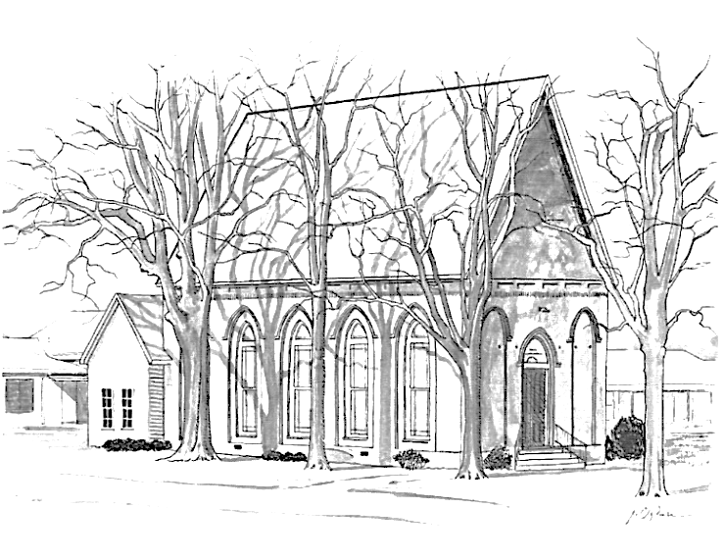

Olivet Presbyterian Church
McConnells, South Carolina



A member congregation of
The Presbyterian Church in America

Olivet Presbyterian Church
The Lord’s Day, December 14, 2025
Prelude Preparation for Worship
Welcome and Announcements
*Call to Worship Pastor Chip McArthur

*Hymn Congregation
*Invocation and the Lord’s Prayer
*Hymn Congregation
Scripture Meditation Pastor Austin Simpson
Corporate Confession of Sin Unison Reading

Pastoral Prayer
His Tithes & Our Offerings
*Doxology
*Prayer of Thanksgiving
Hymn Congregation
Children’s Message Mr. Austin Simpson
(Children aged 3 to 5 years dismissed to Children’s Church Program)
Scripture Reading
Sermon
*Hymn All
*Benediction
*Offering of Praise 735 The Gloria Patri Congregation
*Postlude
*Those who are able, please stand.

Today’s Schedule
8:50 am Early Prayer (Pastor’s Study)
9:00 am Sunday School
10:00 am Morning Worship Service
5:00 pm Choir Practice
This Week at Olivet
Wednesday Youth Group Meets, 6 pm (Fellowship Hall)
Prayer Meeting, 7 pm (Conference Room)
Looking Ahead (Please Mark Your Calendars!)
December 24 Christmas Eve Communion Service, 5 pm
January 4 Communion Service
January 12 Ladies’ Circle, 7 pm
January 18 Joint Officers Meeting, 2 pm
January 24 Fellowship Presbytery Meets a Trinity PCA in Van Wyck
Faith Promise for World Missions
2025 Faith Promise Pledged, April 30, 2025 $ 14,460.00
2025 Faith Promise Received to date $ 9,910.00
Church Budget Matters
Receipts to Date $ 217,514.31
Budget requirements to Date $ 220,983.29
Difference -$ 3,468.98
Collection Duty
December John Hawley, Michael Laws, Brent Christenberry
Nursery Team
Today (12/14) Carson Simpson, Nora Kaye Summerville
Next Sunday (12/21) Kathy Fairfax, Maddie Sikes
Children’s Church Team
Today (12/14) Michael Laws, Marsha Plyler
Next Sunday (12/21) Lorie Hawley, Toni Clinton
Devotional Guides
The latest editions of Our Daily Bread and Tabletalk are now available in the vestibule. Pick up your copy today.

Missions Prayer Requests For December
All the ends of the earth shall remember and turn to the LORD, and all the families of the nations shall worship before you, Psalm 22:7
Peter and Diane Bakelaar (MTW Japan)-Pray that God will be glorified and that lives will be transformed in Japan through the ministry of Nani art gallery.
Mission to the World- MTW asks us to pray for peace within the PCA.
Brian Howard (RUF-I Clemson) -The end of the semester is Dec. 12. Pray that the Lord will bring many to the Christmas party that haven’t attended an RUF-I event so that there will be new opportunities for ministry, conversation, and sharing the gospel.
Sara Driggers (Wycliffe) - Sara asks us to pray for her daughter Taylor who just became engaged and is planning her wedding. Pray for Marty who had a fall at work and will be having rotator cuff surgery on Dec. 12. Also pray for the change in leadership in Sara’s department at Wycliffe. This change brings many adjustments for everyone. Pray for a smooth transition.
Please remember to pray for all our missionaries and to continue our financial support through giving.
Peter and Diane Bakelaar (MTW-Japan)
Brian Howard (RUF-I Clemson Univ.)
Garry and Anita Chambers (MTW-Caribbean)
Sara Driggers (Wycliffe)
Roger and Laura Dye (Family Life – U.S. Latino)

